Protect Our Local Open Spaces
A very special piece of land will be changed forever… IF the Robbinsville Zoning Board gives final approval to a 500,000 sq ft warehouse complex at Mercer Corporate Park, located on Route 526, Robbinsville/Allentown Rd. This project is threatening one of the top birding “hotspots” in NJ with nearly 200 observed bird species sighted there.
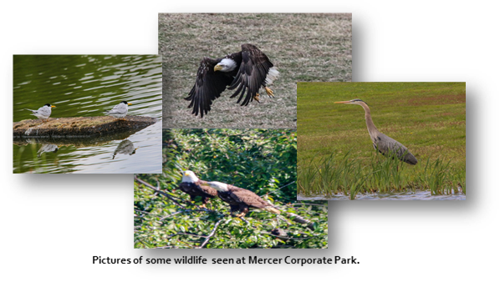
IF this warehouse complex is approved, residents will experience
- Heavy traffic congestion with an additional estimated 250 truck and 400 car trips EACH DAY
- Damage to infrastructure – more roadway repairs, increased flooding and damage due to flooding
- Destruction of wetlands and habitat for threatened and endangered wildlife
- Noise and air pollution
- Security issues as seen by residents near the Matrix complex
WE NEED YOUR HELP! Together, we can make a difference!
- Sign the online petition to prevent the degradation of a special property and the environment. Go to https://www.change.org/TASCTogether
- To receive important updates, announcements, and future Robbinsville Zoning Board meeting information, go to TASC1@googlegroups.com and provide your name, email address, and cell phone number.
- For more information, join us on Facebook at TASC The Alliance for Sustainable Communities Mercer-Monmouth.
- Please consider making a contribution to this worthy cause. Checks can be made out to: Crosswicks Doctors Creek Watershed Association/ TASC, P.O. Box 662, Allentown, NJ 08501. TASC has hired an attorney that specializes in land use and environmental law. All donations are tax deductable.

https://www.njspotlight.com/2021/04/robbinsville-mercer-county-nj-major-warehouse-development-farmland-landing-site-migratory-birds-truck-traffic-choking-roads/

